GitHub link:

[Deja-R-Git/csd-340: Web development with HTML course with Professor Sue Sampson](https://github.com/Deja-R-Git/csd-340)

Local directory:

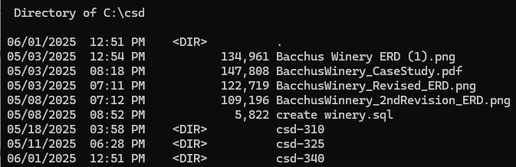

GitHub Landing Page

